# Hair Fall Products: -

1. **Cureveda GROW**

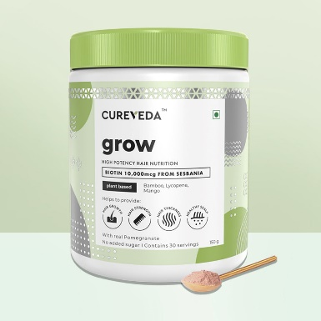

₹ 995.00

High-potency 10,000 mcg biotin sourced from the herb Sesbania. Contains antioxidant lycopene to provide nourishment for stronger, longer, and healthier hair.

2. **Zandu Ayurvedic Hair Growth Vitalizer Capsules**

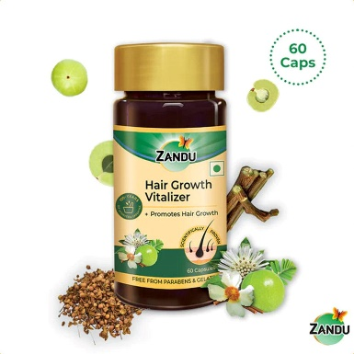

₹449.00

Introducing Zandu Hair Growth Vitalizer Capsule, a scientifically proven Ayurvedic supplement for hair growth, scalp protection, hair fall control, and delayed greying, while providing optimal nourishment to hair.

Zandu Hair Growth Vitalizer Capsule is one of the best capsules for hair growth and health. It is formulated with the goodness of natural ingredients and herbs such as Bhringaraja, Amlaki, Manjishtha, Nagkesara, Ashwagandha, Brahmi, Abhrak Bhasma, and Godanti Bhasma.

Developed by ZAARC (Zandu Advanced Ayurvedic Research Centre), you can be assured that you are opting for more than 100 years of quality and trust.

3. **Kesh King Ayurvedic Hair Growth Capsule**

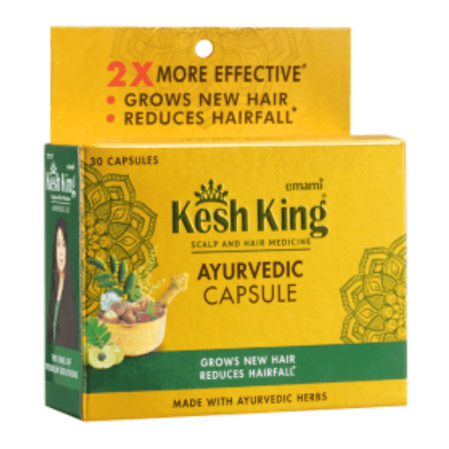

**₹150.00**

[**Kesh King Ayurvedic Capsule**](https://shop.keshking.com/product-category/ayurvedic-hair-capsule/)**is an Ayurvedic Patented Hair medicinal preparation without side effects. Kesh King Ayurvedic Capsule is a complete Ayurvedic formula, which is prepared using 6 selected herbs found in the nature. According to Ayurvedic texts these herbs works as Sanjeevani for hair strands. Kesh King Ayurvedic Capsule not only helps in protecting and nourishing the hair but also prevents premature greying,**[**dandruff, hair fall, split hair**](https://keshking.com/blog/dealing-with-dandruff-in-winter-with-ayurvedic-hair-care/)**and checks loss of hair, sleeplessness and headache. For Chronic hair problems, regular use of**[**Kesh King Ayurvedic Medicinal Oil**](https://shop.keshking.com/product/kesh-king-ayurvedic-medicinal-hair-oil-50ml)**along with**[**Kesh King Anti Hairfall Shampoo**](https://shop.keshking.com/product/kesh-king-ayurvedic-anti-hairfall-shampoo-600ml/)**& Capsules is advised for at least 21 Days. It helps in**[**regrowth of hair**](https://keshking.com/blog/top-5-reasons-for-hair-fall/)**. Hair consists of two parts - the hair follicle and the hair shaft. Kesh King Ayurvedic Capsule helps in increasing the blood circulation to the follicle which is the center of biological activity like hair growth and pigmentation. It is documented that Kesh King Ayurvedic Capsule works like a tonic and gives nutrition to Matrix Cells. These activated Matrix Cells remove the fiber of weak hair and helps in activating new hair fiber, resulting in stronger, longer and dense hair.**

**4. OZiva Hair Vitamins**

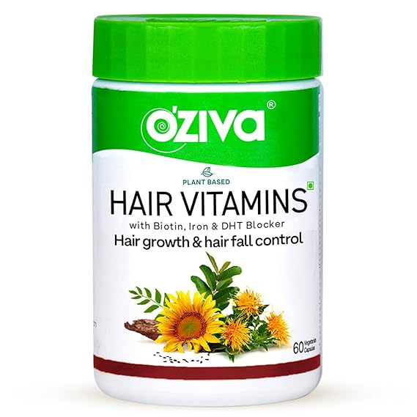

**₹899.00**

**OZIVA HAIR VITAMINS FOR HAIR GROWTH & HAIRFALL CONTROL: Formulated with 100% pure plant extracts, OZiva hair growth capsules for women and men nourish hair roots and strengthen hair follicles to reduce hair fall and improve hair growth. OZiva is India’s #1 Hair Supplement with Clinically Proven SesZenBioTM.**

**CLINICALLY PROVEN FORMULA WITH SESZENBIOTM - Powerful and potent plant active SesZenBioTM has been clinically proven to grow 10800 new hairs over 4 months in both women and men. 96% of users have seen positive results with regular consumption.**

**PLANT BASED IRON, BIOTIN & ZINC: OZiva Hair Vitamins offers plant based multivitamins along with Biotin for hair extracted from Sesbania Agati Plant, 3.5% Iron from Curry leaves and 4% Zinc from Guava leaves along with Vitamin E and Brahmi. The proprietary formulation with these standardised extracts provides a multi-targeted solution for hair fall caused by various factors like nutritional deficiencies, hormonal imbalance, stress and pollution.**

**NATURAL DHT BLOCKER: Excess DHT hormone in both men and women leads to shrinking of hair follicles and hair falling out. OZiva Hair Vitamins with 4% Zinc from Guava leaf extract blocks these excess hormones and strengthens the hair follicles for improved hair growth.**

**5. Kachasan Tablet 60 Tabs**

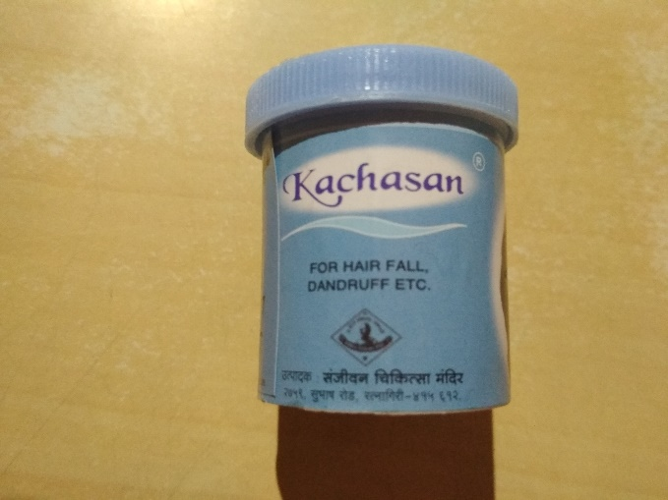

**₹100.00**

Kachasan tablet is a product of Sanjeevani Chikitsa mandi meant to deal with all you hair related issues. Are you tired of losing hair due certain reasons, but want to take chemical treatments? Here’s the best chemical free way to help your hair look voluminous and lustrous. Kachasan tablets are ayurvedic compositions that help treat your hair from scalp to roots. The formulation effectively eradicates dandruff, dryness and dullness from hair. It instantly stops hair loss and promotes the production of keratin in your hair to help you get your dream hair waves. The formulation works effectively on all skin and hair types to treat all hair problems. Say goodbye to dry and frizzy hair forever with the Kachasan tablet.

# Skin care products: -

6. **Divyaa's Divine Kumkumadi Oil**

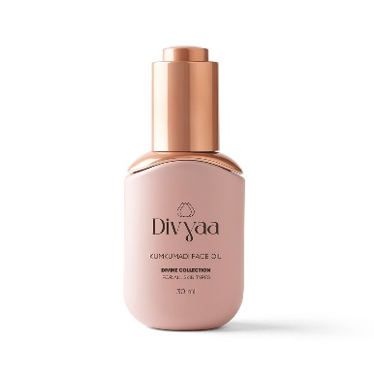

**₹**4,000.00

Experience the magic of 100% pure facial oil with Divine Kumkumadi Face Oil from Divyaa. Suitable for all skin types, this nourishing oil effectively tackles signs of ageing, pigmentation, and blemishes. Achieve improved skin texture and a radiant complexion with this non-comedogenic, age-defying oil with ingredients like Saffron, Turmeric, etc.

7. Himalaya Wellness Pure Herbs Brahmi Mind Wellness

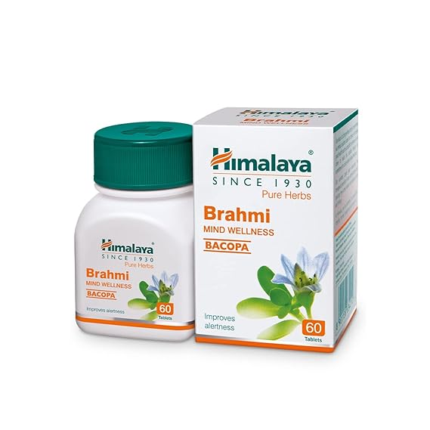

₹200.00

Brahmi helps calm the mind, promote clarity of thought, and memory consolidation.

Brahmi is used as a memory -enhancing agent from centuries.

Brahmi promotes mental health and cognitive skills.

Brahmi calms and relaxes mind.

8. **Saffron Extract Capsules**

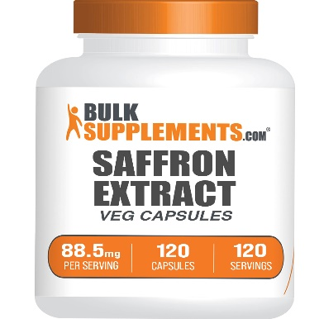

**₹**2,000.00

Saffron extract capsules, derived from the vibrant stigmas of the Crocus sativus flower, capture nature's elegance in a potent, easy-to-consume form. These capsules are not only a testament to the flower's delicate beauty but also to the meticulous care and precision involved in its harvesting. This process, steeped in tradition, combines wellness with a touch of luxury, offering a unique way to incorporate the benefits of saffron into your daily routine.

9. **Zandu Neem Tablets**

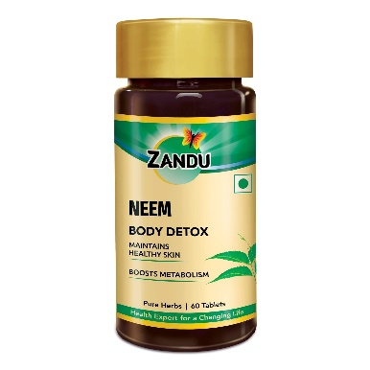

₹200.00

Are you looking to make your skin radiant, healthier, and clearer? Zandu Neem Tablets can help you achieve this. These tablets are formulated using 100% pure Neem Extract to restore your skin's health. Neem works as an antiseptic, making it beneficial for your skin and helping to prevent infections such as acne and rashes.

These Neem Tablets are crafted after careful consideration of your daily health needs and are enriched with the goodness of pure Neem herb. Experience the power of nature with Zandu Neem Tablets, meticulously made with pure Neem extract to rejuvenate your skin and address common skin concerns.

With Neem's antiseptic properties, these tablets serve as your shield against acne and rashes, promoting clearer and healthier skin. Zandu Pure Neem Tablets are developed by the experienced Ayurvedic Experts of ZAARC (Zandu Advanced Ayurvedic Research Centre) and hold the 200-year legacy and trust of Zandu.

Regular consumption of Neem in its purest form ensures long-term benefits, including youthful and radiant skin. Start consuming Zandu Neem Tablets and watch your skin become cleaner day-by-day.

10. Zandu Ashwagandha Capsules for Stress & Anxiety

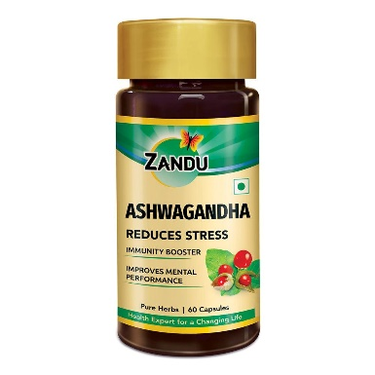

₹250.00

Zandu Pure Ashwagandha capsule is formulated with the finest quality standardized Ashwagandha. Ashwagandha commonly known as **Asgandha**, is a small shrub found in drier parts of India, the Middle East and regions of Africa. As per Ayurveda, the roots, leaves and seeds have been used for medicinal purposes for centuries.

Zandu Ashwagandha capsule is a safe supplement and delivers the same natural properties of Ashwagandha in a convenient and easy-to-consume form to ensure that you consume the correct amount of the herb in every intake. Zandu Ashwagandha capsule helps to boost your immunity, manage stress levels naturally and improve mental performance.

We believe that the practice of ancient Ayurveda is essential, especially in today’s fast-paced world. It is easy to fall for untested remedies and misinformation with so much exposure to unverified information.

Fad diets and lifestyle trends keep coming and going. In such a scenario, relying on time-tested solutions backed by centuries of Ayurvedic wisdom is prudent. With Zandu Ashwagandha capsules, get **2x* boosted immunity** and better stress resistance naturally and effectively.

11. **Pure Nutrition Shatavari Extract Tablets**

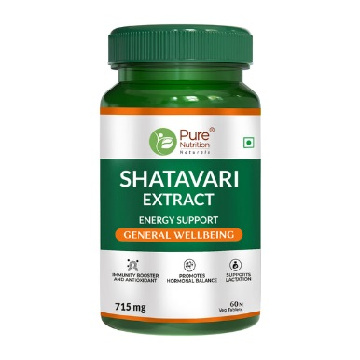

₹499.00

Experience the natural benefits of Pure Nutrition Shatavari Tablets, designed to support your immune system and provide powerful antioxidant protection. Shatavari, a revered herb in traditional medicine, is known for its ability to enhance immunity and fight oxidative stress. Our 100% natural tablets are perfect for those looking to improve their overall health and vitality. Each bottle contains 60 vegetarian tablets, providing a two-month supply of wellness support.

12. **Cureveda GLOW**

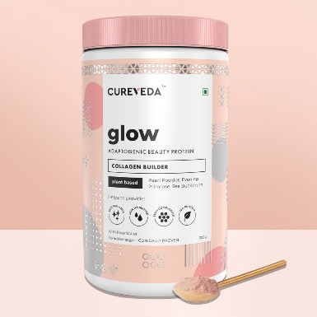

₹1,395

A power packed plant-based formula to boost collagen synthesis and provide skin radiance, skin hydration, UV protection and 9.6gm of veg protein- 100% Vegetarian, 100% Natural! Get your GLOW on with Cureveda’s Glow powder – healthy inside, beautiful outside! Enriched with luxurious Pearl Powder – For the first time in India! A legendary beauty ingredient, our Pearl comes from sustainable, fresh water farms. Our pearls are levigated with rose water, and then a pinch is added to the herbal blend to meet the daily dose for stimulating collagen production in the body, skin brightening and for clear glowing skin! Look good and feel great with Cureveda’s plant-based Glow blend, carefully crafted to rejuvenate the body and the soul.

13. Himalayan Organics Skin Vitamin with Hyaluronic Acid

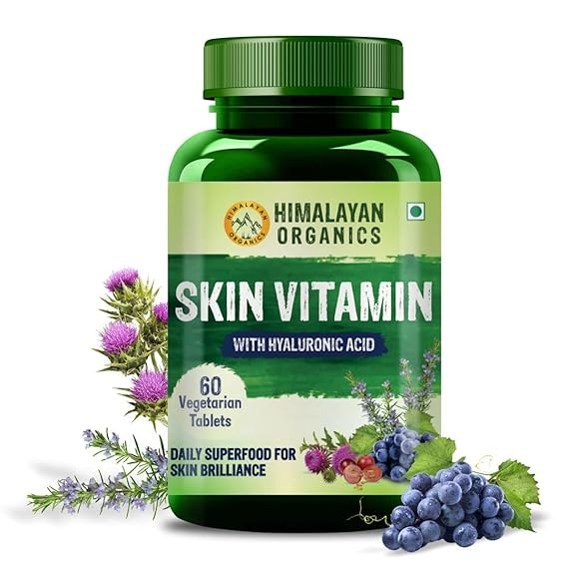

SMOOTH & GLOWING SKIN: Collagen synthesis is essential for soft, smooth, supple & radiant skin. Vitamin C & Vitis Vinifera Extract (Grapeseed) are superfoods to enhance collagen production in your body to improve your skin strength & firmness. Vitamin B3 enhances your skin barrier functions allowing your skin to be more soft, supple, smooth & naturally glowing.

INTENSE HYDRATION: As you age, the moisture in your skin decreases, making your skin dull & lifeless. Himalayan Organics Skin Vitamin Tablets have 3.4% of hyaluronic acid, Vitamin B3 & Vitamin B5 that intensely hydrates your skin cells, deeply moisturizes for smooth skin texture, enhances skin firmness & improves the quality of your skin.

BLEMISH-FREE SKIN: Himalayan Organics Skin Vitamin tablets are loaded with nutrients & plant-based extracts that have effective intrinsic properties. Nutrients like Vitamin A, Vitamin C, Vitamin D & Vitamin E are rich in antioxidants, anti-inflammatory & anti-aging properties that combat environmental damage, regulate the appearance of fine lines & discourage blemishes for crystal clear glowing skin.

14. Himalayan Organics Naturally Sourced Astaxanthin

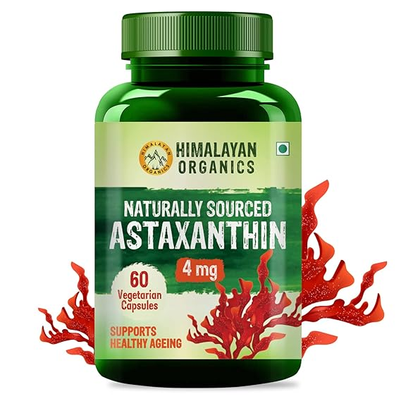

₹1099.00

Himalayan Organics Brings To You Naturally Sourced Astaxanthin For A Healthy Lifestyle. Astaxanthin Is Not Just A Potent Antioxidant Powerhouse But Is Also Jam-Packed With Various Anti-Inflammatory & Anti-Fatigue Properties For Notable Health Benefits. Astaxanthin Is A Marine-Based Antioxidant Crowned As "King Of The Carotenoids" Because It Is Five Times More Potent Than Beta-Carotene & Several Thousand Times More Powerful Than Vitamin C.  
  
It Supports Healthy Skin Aging, Smooth Heart Functioning, Active Cognitive Functioning & Better Vision. Not Just That, Its Unique Structure Safeguards The Cells From Both Internal & External Oxidative Stress, Essential For Healthy Bodily Functioning. Now Aging Does Not Seem Difficult With Himalayan Organics Naturally Sourced Astaxanthin Capsules. Healthy Aging, Powerful You!

15. **Gynoveda Lung Detox Ayurvedic Tablets**

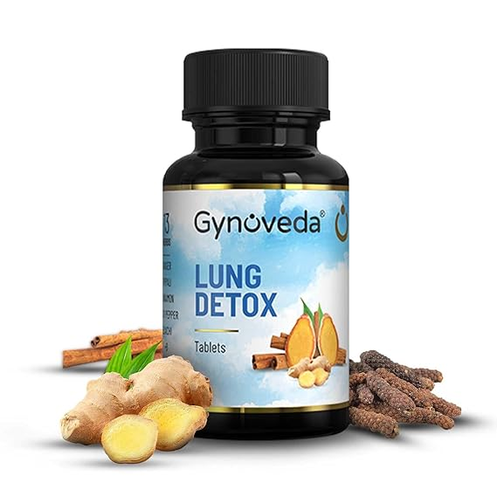

₹1,200.00

Detoxifies lungs to reduce congestion & ensure easy breathing in smokers. Flushes out tar, mucus from respiratory tract to support better oxygen absorption. Reduces seasonal discomfort, allergies, breathing issues due to pollution. Supports lung, bronchial & respiratory functions to help prevent any damage. Reduces frequent cough, cold, infections by improving immunity. Breathe easy with tar-free, healthy lungs, lifelong.

16. **Ayurveda Redefined Multi Vitamin Tablets**

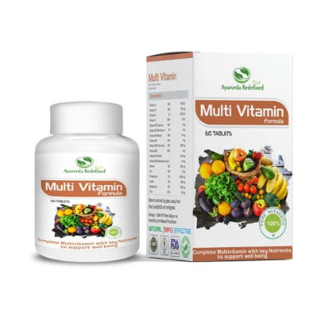

₹250.00

It includes 12 vitamin, and 6 essential natural minerals for overall well being.

It imparts healthy skin and hair.

It protects vital organs and acts as stamina booster.

It strengthen bones and increases immunity.

Ideal for sportsman in fighting mineral deficiency.

It improves blood circulation and helps in increasing metabolism.

17. Baidyanath BrainTab

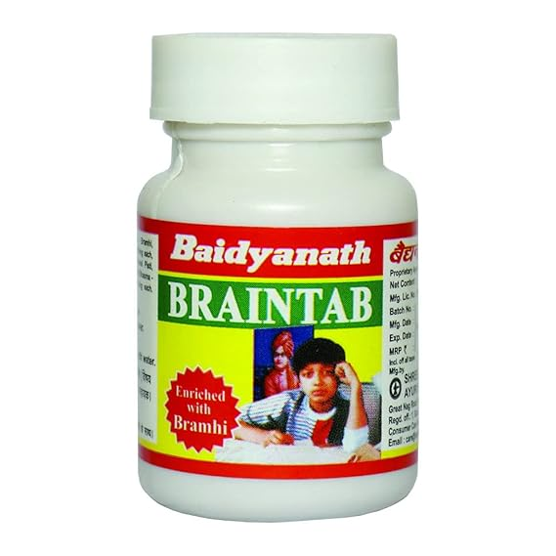

₹240.00

**Baidyanath Brain Tab Tablet is** an ayurvedic medicine in tablet form, used in the treatment of depression and blood pressure. This medicine should only be taken under strict medical supervision. This medicine is most commonly used in north Indian ayurvedic practice. The medicine brahmi as its main constituent. This is a unique drug having its direct effect on the nervous system. Brain Tab helps increase certain brain chemicals that are involved in thinking, learning and memory.

18. Himalayan Organics Digestive Enzyme

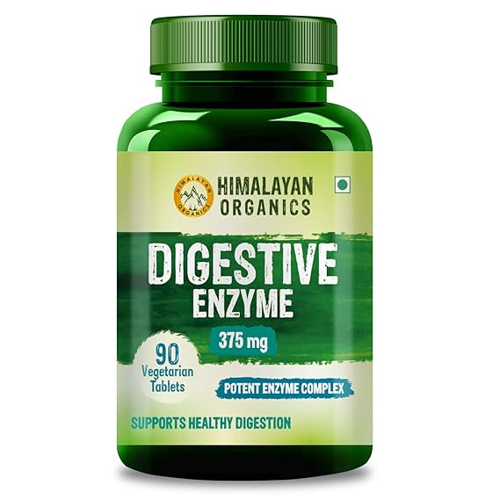

₹949.00

NUTRIENT ABSORPTION: Himalayan Organics Digestive Enzyme Capsules are a unique blend of enzymes that break down fat, carbohydrates, proteins & nutrients to release the required amount of energy. This is one of the best digestive supplements helpful in a number of digestive disorders.

1 TABLET DAILY FOR SMOOTH DIGESTION: Himalayan Organics Digestive Enzyme can be taken to relieve digestion problems effectively. It contains a range of digestive enzymes that enhance digestion efficiency along with decreasing fatigue to keep you refreshed throughout the day.

19. **Cureveda Ignite Immunity**

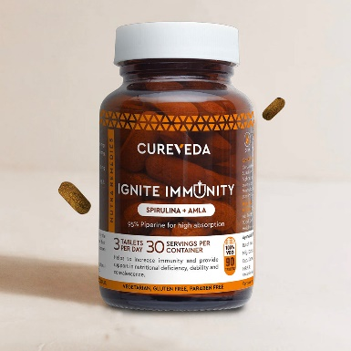

**₹1,145.00**

**Contains purest quality Spirulina tested for heavy metals & contamination to boost immunity & provide essential vitamins and minerals. A high absorption formula enriched with Amla further contributes to the overall nutritional value, providing an additional dose of Vitamin C.**

20. **Fytika Immunity Booster**

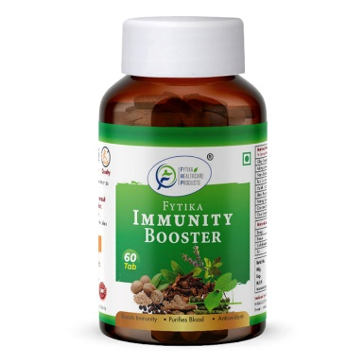

**₹999.00**

Fytika Immunity Booster is packed with natural immune-boosting ingredients such as Giloy, Tulsi, Ashwagandha, Neem, Clove, and Cinnamon. It fortifies your body's defences, enhances your immune response, and supports overall health.

# Sleeping and Relaxation

21. NutroEdge **Sleep and Focus**

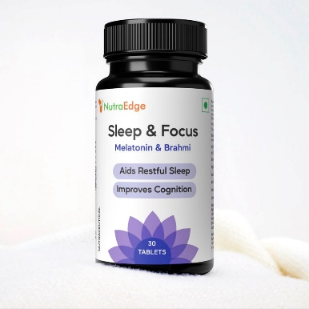

₹699.00

Sleep & Focus is meticulously designed to guarantee a restful 6-8 hours of sleep. Melatonin works to balance your sleep-wake cycle and improve insomnia and other sleep disturbances. But that's not all; it also contains Brahmi. Known as Bacopa Monnieri, Brahmi enhances mental clarity, diminishes anxiety, boosts memory, and combats mental tiredness. With Sleep & Focus, you not only enhance your sleep quality but also amplify your productivity.

22. **Cureveda SleepSure**

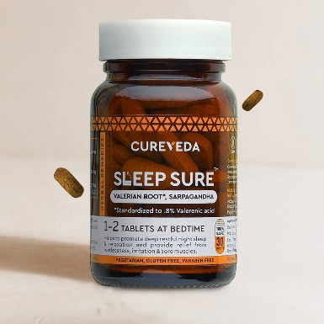

₹995.00

Your partner for healthy, uninterrupted sleep - completely naturally! Contains no synthetic ingredients and is made with researched herbs to start showing results in only 15 days. Sleep better with less night awakenings and at a long stretch of 8 hours.

23. **Organic India, Peaceful Sleep**

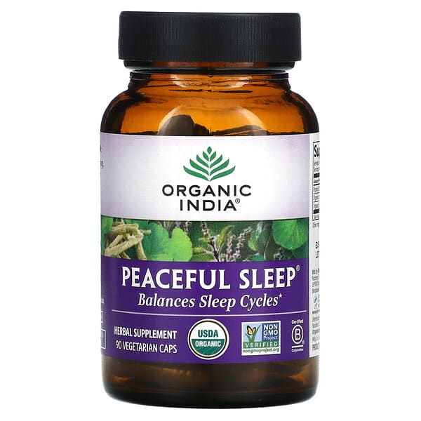

**₹1,820.00**

Balances Sleep Cycles, USDA Organic, Non GMO Project Verified, Certified B Corporation, Herbal Supplement, Halal, Kosher, Vegan, Vegetarian, Gluten Free, Certified Organic by Control Union.

Whole herb solutions for healthy conscious living, grown sustainably by small family farmers using regenerative organic agriculture.

24. **Cureveda Stress Shield**

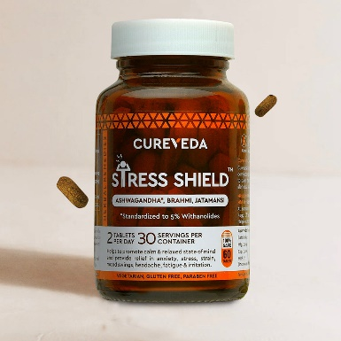

₹1,395.00

A triple-action formula designed to regulate stress, support mental cognition, and promote a calm mind. This blend contributes to general well-being and helps balance stress hormones. Ashwagandha aids in calming the mind, while Jatamansi assists in combating exertion.

# **Joint and Muscle Tablets**

25. **Cureveda Joyful Joints**

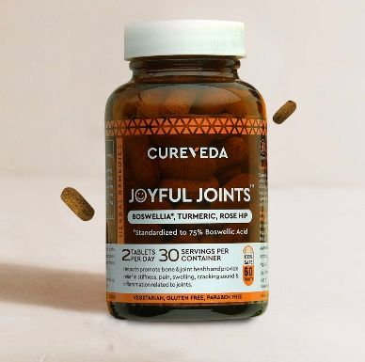

**₹995.00**

Triple action formula which maintains flexibility in knees, wrists, legs and back. Useful in preventing degradation of joint cartilage. Unlike NSAIDs, this formula avoids causing gastric and heart issues and features Boswellia, Rosehip, and Curcumin for joint support.

26. **Swisse Joint Repair**

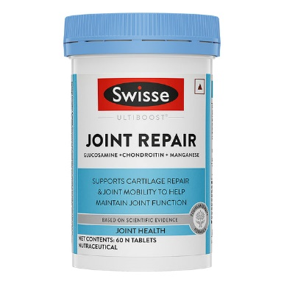

₹2,399.00

Helps joint flexibility: Glucosamine helps maintain the strength and elasticity of joint cartilages by supporting the human body’s natural cartilage repair process.

Relieves mild joint pain: These joint repair capsules contain Chondroitin and Glucosamine. Chondroitin helps improve joint mobility and relieves joint pain associated with osteoarthritis of the knee. Glucosamine assists in the management and symptomatic relief of osteoarthritis.

Protects cells against free radical Damage: Manganese present in these joint repair capsules is an essential mineral involved in formation of connective tissue, maintenance of normal bones and plays a role in protecting cells against free radical damage.

Increases muscle health & function: Both chondroitin and glucosamine sulphate help the body maintain joint function and mobility.